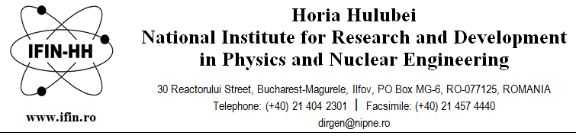
“Horia Hulubei” National Institute for Research and Development in Physics and Nuclear Engineering is hiring 6 scientific research assistants or scientific researchers for a definite duration, until 30th September 2022, full time, within the Department of Nuclear Physics (DFN).
Requirements for filling the position:
- master/doctoral programme student in nuclear physics/engineering, technological physics, or applied physics or PhD in physics/engineering;
- Knowledge of IT, C++ programming, mathematical data processing software, simulation software;
- Foreign languages: English, very good;
- Knowledge of the topics and bibliography specified in the announcement;
- Personal availability to start work in max 30 days from the interview.
Skills and abilities: team player, communication skills, working independently.
Main responsibilities:
- Acquiring the knowledge required to fulfil tasks specific to the Nuclear Physics Department;
- On-going training and honing in the field of the position topics;
- Taking part in measurements using the detection systems from IFIN-HH;
- Taking part in the data processing using the detection systems from IFIN-HH;
- Conducting Monte Carlo simulations necessary for interpreting and processing the experimental data;
- Taking part in various specific IT support activities.

Applications will contain the following documents:
- The request to register for the competition is found at www.nipne.ro/careers/jobs/jobs.php, specifying the name of the department;
- Copies of study diplomas (baccalaureate included);
- Translated copies of diplomas. Recognition and equivalence of studies according to the required procedure (available at www.cnred.edu.ro/en) - for foreign diplomas
- Curriculum Vitae;
- Certificate indicating enrolment in a doctoral programme;
- Copy of the identity document/passport.

The competition will consist of a written test and an interview in the field of the position topics.
The interview can be held only by the candidates who have obtained a minimum score of 7 in the written test.
The candidates who have obtained a minimum score of 7 at the interview are declared admitted. The final score is calculated as arithmetic mean of the scores obtained for the written test and the interview and must be at least 7. The candidate who has obtained the highest score among the candidates competing for the same position is considered admitted, provided that they have obtained the minimum necessary score.

The applications will be sent to e-mail address resum@nipne.ro, until 08.12.2021.
The written test and the interview will take place on 10.12.2021 at 10:00.
Additional information can be obtained by calling +4 021/404.61.78 or +4 021/404.23.00 extension 5612, 5610.

Topics: General notions of:
- radiation interaction with matter;
- elementary particles;
- dosimetry, radioprotection, particle detection.

Bibliography:
- William R. Leo - Techniques for Nuclear and Particle Physics.
- Gh. Vlăducă, Elemente de fizică nucleară, Editura Universităţii din Bucureşti, 1988 (vol. I), 1990 (vol. II);
- I. Lazanu, Particule elementare. Probleme rezolvate, Editura Universităţii din Bucureşti, 2002;
- I. Lazanu. O. Ristea, Fundamental in Nuclear Physics, Experiments. http://brahms.fizica.unibuc.ro/fanpeaa/descarca/Fundamentals.pdf

